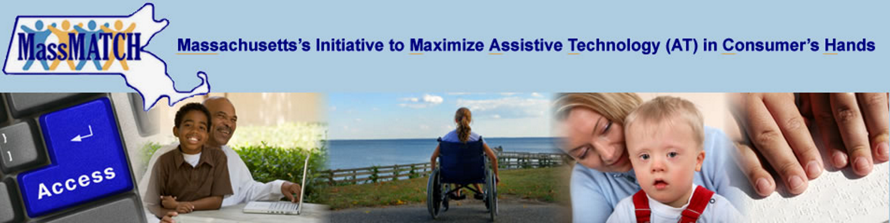

Success with Technology

2014 Annual Report
The mission of MassMATCH is to promote the use of assistive technology and assistive technology services to enhance the independence of people with disabilities, enabling equal participation in all of life's activities


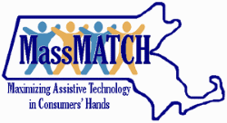
About MassMATCH
MassMATCH is the statewide Assistive Technology Act Program funded through the Rehabilitation Services Administration, US Department of Education. It is a program of the Massachusetts Rehabilitation Commission and one of 56 statewide programs made possible by the AT Act of 1998 as amended in 2004.
MassMATCH programs provide access to learning about and acquiring assistive technology by individuals with disabilities, family members, seniors and professionals who provide AT services. MassMATCH partners keep up with the latest technologies and the solutions they can provide. Our initiatives serve individuals of all ages, in all environments, across the range of disabilities.
Today technology is revolutionizing the way everyone lives, learns, works and plays. For persons with disabilities, there has never been a time with more potential for equal access to all of life’s activities. Visit us at MassMATCH.org.

What is AT?
Assistive Technology (AT) is any item, piece of equipment or system that increases, maintains or improves the functional capabilities of individuals with disabilities. Assistive technology devices help individuals with disabilities do what they are able to do better and longer. AT ranges from a simple pencil grip to specialized equipment such as a power wheelchair and includes specialized software or consumer electronics with built-in accessibility features.

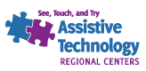
Assistive Technology Regional Center (ATRCs)
MassMATCH partners with Easter Seals MA and United Cerebral Palsy (UCP)-Berkshire to provide AT Regional Centers in eastern and western Massachusetts. The Centers welcome the public to come see, touch and try the latest AT devices without pressure to choose any particular product. Information & assistance, trainings, AT demonstrations, as well as short-term device loans are FREE services provided by the ATRCs. The Centers are located in Boston and Pittsfield.

Learning About AT

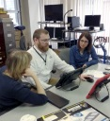
AT Demonstration and Short-Term Loans
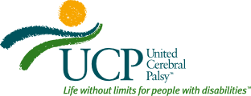
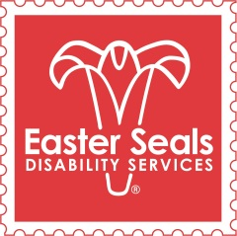
Device demonstration is the opportunity for an individual or group to see AT in action. Individuals with disabilities, their family members, teachers, therapists and others come to the centers to learn about new AT products, and find AT solutions appropriate to their or their clients’ needs, desires and functional capabilities. Short-term Device Loans allow individuals to try devices for up to four weeks at a time in their intended environments. Both services allow users to make informed decisions or help fulfill short-term equipment needs.
Search or browse the device loan inventory online at massmatch.org/find_at/borrow.php
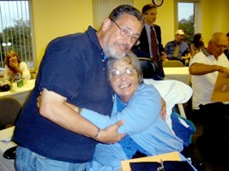
ATRC Demo/Loan Activity | 2014
# Devices Loaned | 864
# Device Loan Participants | 523
# Demonstrations | 211
# Demonstration Participants | 377
Categories of Demo/Loan Participants in 2014 | Categories of AT Loaned and Demonstrated in 2014
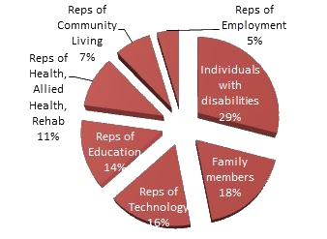 | 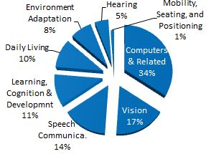

Success Spotlight: AT Regional Center
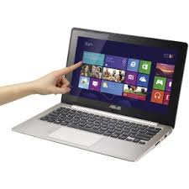
During 2014, a sixteen-year-old young man and his mother visited the ATRC in Boston to explore access options for a computer. “Sam” had excellent computer skills, but his hands were damaged in a fire that had scarred over 90 percent of his body. The ATRC staff helped Sam try gestures on a tablet, a head stylus, and finally a hand stylus secured with Velcro. With the hand stylus Sam discovered he had the most control. Sam used it with the Asus Vivobook touch-screen laptop and the Microsoft Surface Pro tablet, and learned he preferred the laptop’s larger screen. He also discovered he could make the stylus work the Asus keyboard. Sam was excited. Now he could get back to playing video games, communicating with his friends on social media and, generally, to feeling like a teenager.

Information & Assistance, Training, and Public Awareness
MassMATCH responds to requests for training and information and assistance (I &A) directly and through its AT Regional Centers. Information is provided about AT devices and services, about how to access funding for AT, and on other related disability topics. Trainings also address a range of issues that are targeted to their audience.
During 2014:
- 1,307 individuals received information and assistance. 34% were representatives of health, allied health and rehabilitation; 25% were individuals with disabilities and 17% were family members.
- 809 individuals attended AT trainings statewide. 134 individuals attended trainings addressing transition-related topics. 54% of training participants were representatives of health, allied health, and rehabilitation. 13% were representatives of education.
- 337,073 individuals were reached through public awareness activities such as the Internet, print and digital newsletters, email notices, PSAs, presentations, expos, and conferences.
 | 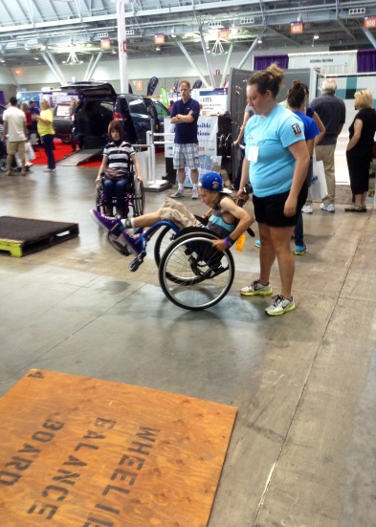 | 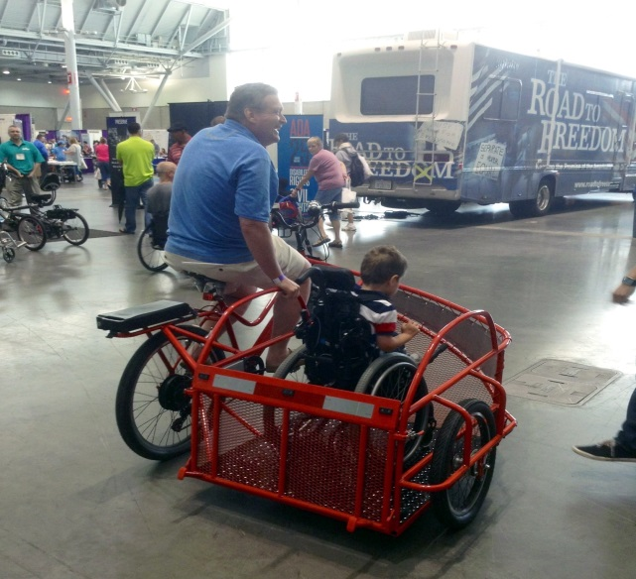 | 2014 Abilities Expo Boston attendees. MassMATCH has worked to bring Abilities Expo back to Boston as an annual event that celebrates AT.

Acquiring AT


Device Financing: The Massachusetts AT Loan Program
MassMATCH partners with Easter Seals MA and the Santandar Bank to enable persons with disabilities to purchase AT and AT services (such as training with devices). The AT Loan Program makes financial loans accessible to people who may ordinarily be turned down by traditional lenders and does so with favorable rates and terms. The Massachusetts AT Loan Program is one of the oldest AT financial loan programs in the country. Since inception it has made over $11 million in loans for the devices and AT services that consumers want and need. The loans are commonly used to help purchase modified vehicles, adapted computers, computer software, durable medical devices and portable ramps.
- During 2014 the AT Loan Program loaned $526,921 to 39 borrowers. 70% of applicants had annual household incomes of $30,000 or less. The applicant approval rate was 64%, and the program’s default rate was 3%.
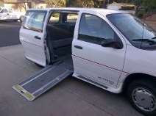

Success Spotlight: AT Loan Program
During 2014 the AT Loan Program assisted a young woman with no credit history to purchase a wheelchair accessible van. “Jan” had experienced a spinal cord injury in her teens and had since depended on accessible public transportation. She approached the AT Loan program to purchase her own van so she could more reliably get to appointments, buy groceries and look for employment. The AT Loan Program negotiated on her behalf with the program’s lender, and Jan’s application was eventually approved. Jan was thrilled with the support she received, the understanding she felt through the process and especially for her new found independence. She has since purchased her van and found employment!

Reuse Initiatives
MassMATCH helps gently-used assistive technology and durable medical equipment to find a second life in the hands of people who can most benefit by it. Seniors, veterans, adults and children with disabilities obtain AT for free or at a reduced cost through MassMATCH reuse efforts. These initiatives include long-term (“open-ended”) equipment loans, device exchange and reassignment programs.

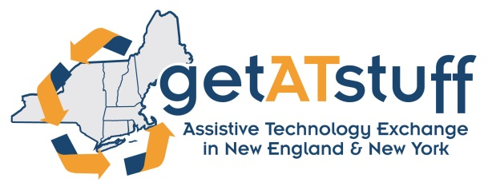
Get AT Stuff.org—The AT Exchange of New England and New York
GetATStuff.org is the website of the Assistive Technology Exchange in New England and, as of 2014, New York! The exchange offers a free "classified ad" so people can buy, sell, give away, or post their need for equipment (on the website we call it a “virtual AT porch sale”).
- During 2014 there were 28 completed exchanges saving consumers an estimated $115,643 over retail. There were also 275 new users registered on the website.

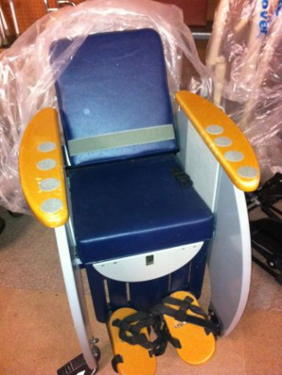
Device Exchange | 2014 | Since Inception (2008)
Savings to Consumers as Reported by Sellers | $115,643 | $530,758

The Long-Term Device Loan Program
The MassMATCH Long-Term Device Loan Program, administered by Easter Seals, provides devices valued at under $500 to applicants who demonstrate financial need. Borrowers may keep the equipment for as long as necessary. Easter Seals purchases new devices based on applicant needs and when these items are no longer used, they are returned and made available to future borrowers.
- During 2014, the program saved 81 borrowers a total of $24,845. The program provided hearing and vision aids, mobility aids, computers and other devices for learning, cognition and development.

REquipment
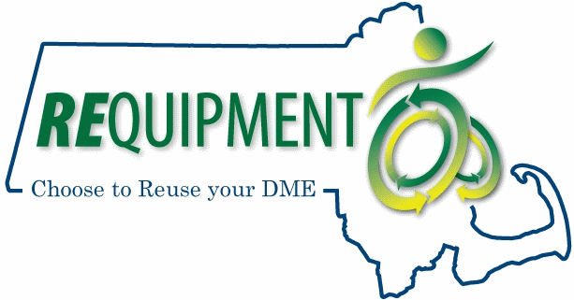
REquipment is a durable medical equipment (DME) reuse program serving Greater Boston and now Central Massachusetts. REquipment refurbishes donated wheelchairs, ramps, shower chairs, rollators, adapted strollers and other gently-used high-quality DME. The program is a unique collaboration between the public and private sectors dedicated to keeping valuable equipment out of landfills and in the hands of persons with disabilities.
- In 2014, MassMATCH partnered with the Department of Developmental Services, The Boston Home, the Mass Hospital School and the Boston Foundation to reassign 44 devices to individuals, families and seniors. REquipment’s durable medical equipment saved these recipients $73,848.

Additional Reuse Initiatives
MassMATCH also supports the efforts of Stavros Center for Independent Living in Amherst to refurbish donated durable medical equipment and find them appropriate new owners.
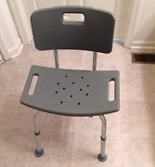
- During 2014, Stavros CIL refurbished and reassigned 146 devices and saved recipients an estimated $350,052 over retail.
Reuse Activity | 2014
Total # Devices Exchanged | 28
Total # Devices Reassigned  (all refurbishment programs) | 190
Total # Long-Term Device Loans | 81
Total reutilized | 299

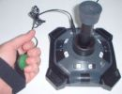 | 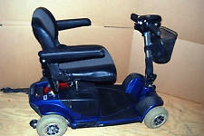 | 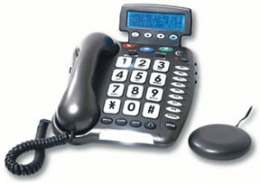 | 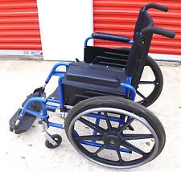

Success Spotlight: Long-Term Device Loan
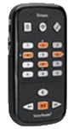
Marie came into Easter Seals with a list of devices she wanted to learn more about to help "feed her head." She explained that recently she'd developed a vision impairment and had subsequently left her teaching job. She was managing on a fixed income, but the problem was she felt detached from the world. Marie was delighted to learn she qualified for the MassMATCH Long-Term Device Loan program and opted to borrow the Victor Reader Stream and Dragon Naturally Speaking Software. The Victor Reader Stream is a mobile device that would allow her to listen to books and music as well as rich media on the Internet. Dragon’s software enables voice navigation of a computer as well as speech-to-text for writing. Both purchases came under the Long-Term Device Loan Program’s $500 limit. Marie is now using them to keep up with current events, communicate, and read. She has told program staff that returning to reading gave her back her independence as well as her dignity.

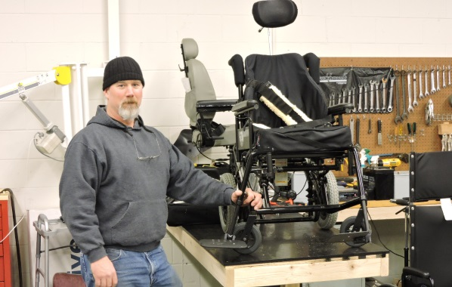
Coordination and Collaboration

DME Reuse Center Comes to Worcester!
MassMATCH and the Department of Developmental Services (DDS) collaborated to open a new DME Reuse Center in 2014. The center is a hub for receiving, refurbishing, and redistributing donated durable medical equipment through REquipment and serves central Massachusetts and Greater Boston.

Money Follows the Person (MFP) Initiative
MassMATCH worked with MassHealth to ensure that individuals needing assistive technology to move home or into the community can access these services. AT services and devices are now billable to MassHealth and 49 additional case workers who assist individuals transitioning out of institutions have been trained to help.


AT School Share (ATSS)
The MassMATCH AT School Share initiative welcomed 5 additional school entities during 2014 and has now registered a total of 25 organizational members. Schools are using ATSS’s online tool to manage their AT inventories. To date, 12 participating school entities have listed inventories, totaling more than 1,300 AT devices.

Mobility and Adaptive Seating Clinics
MassMATCH, DDS, and the Stavros Center for Independent Living collaborate to offer adaptive seating clinics to persons with disabilities living in the Pioneer Valley. 7 individuals were served in 2014.

2014 AT Advisory Council
MassMATCH is advised by a council made up of community members and professionals who understand the importance of assistive technology for persons with disabilities. A majority of the council members (not less than 51%) are individuals with disabilities who use assistive technology or are family members or guardians of individuals who use AT. Other council members are representatives of state agencies concerned with creating better access for people who could benefit from AT.
Consumer Representatives | Family Representatives | Agency Representatives
Jeanette Beal | Karen Janowski | Ann Shor, Mass. Rehabilitation Commission
Julian Banerji | Randi Sargent | Alexander Pooler, Mass Commission for the Blind
Kevin Hatch | Stacey Selfridge | Tory Dixon, Independent Living Centers
Lee Nettles | Susan LaSante | Susan Hargrave, Dept. of Elementary and Secondary Ed.
Linda Sakin | Susan Ventura | Jonathan O'Dell, Mass. Com. for Deaf and Hard of Hearing
Lisa Chiango |  | Jeff Dougan, Mass. Office on Disability
Melodee Whitman |  | Tom Mercier, Dept. of Developmental Services
Owen Doonan |  | Prof. Les Cory, SHARE Foundation UMASS Dartmouth
Peter Gefteas |  | Linda Landry, Disability Law Center
Paul Remy

