TRANSITION ASSISTANCE TO COMMUNITY
LIVING ENVIRONMENT

The goal of this tool is to help identify assistive technology needs of individuals transitioning into community settings, and then direct those individuals and their caregivers to applicable resources. This simple-to-use assessment tool is designed for case managers, social workers, healthcare providers and related agency workers to use in order to determine the need for assistive technology services and possible referral for individuals transitioning out of institutions.

The Transition Assistance to Community Living Environment (TACLE) questionnaire and supplement are resources for identifying these possible assistive technology needs and solutions for people looking to live more independent lives. The questionnaire is designed to help identify areas of independent living (IL) in which someone may benefit from the use of assistive technology (AT). The supplement contains examples of AT in each of the areas of IL considered in the questionnaire.

The resource supplement is not designed to be all-inclusive in terms of AT or resources. The items listed are for information purposes only and do not constitute endorsements or recommendations. This tool was developed by Easter Seals Massachusetts, under the direction of MassMATCH, with funding by the U.S. Department of Health and Human Services under the Assistive Technology Act of 1998, as amended.
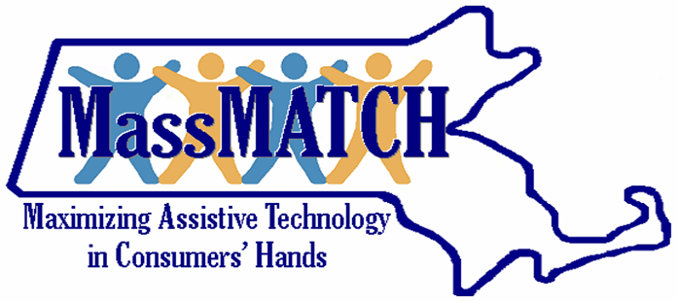 | 
MassMATCH  Massachusetts Rehabilitation Commission  600 Washington Street  Boston, MA 02111  1-877-508-3974  Email: info@massmatch.org  www.MassMATCH.org | Easter Seals Massachusetts  Assistive Technology Program  484 Main Street  Worcester, MA 01608  1-800-244-2756  Email: AT@eastersealsma.org  www.eastersealsma.org
Transition Assistance to Community Living Environment Questionnaire
INSTRUCTIONS
Overview
The questionnaire is designed to be a functional guide to assist with identifying areas of independent living where the consumer may benefit from using assistive technology. The supplement is designed to provide examples of possible assistive technology resources.
The questionnaire is organized by areas of independence rather than disabilities. Since the questionnaire is designed to be a functional guide, you may find that not all sections and questions will be appropriate for every consumer. Use your discretion when deciding which areas/questions would make the questionnaire most functional for you and the consumer. In addition, you may choose to elaborate on questions in order to obtain additional information to help best determine assistive technology needs.

Using the Tool
Follow the guidelines below to help you best select the appropriate answer:
Yes: If the consumer is able to complete the listed task with complete independence.
No: If the consumer is fully dependent on another person in order to complete the listed task, or if the question does not apply.
With Assistance: If the consumer is able to partially complete the listed task without assistance, may require assistance on occasion, or currently uses some form of AT to complete daily tasks.
Comments: Use the space available to record any observations or additional information that may help identify possible assistive technologies at the completion of the interview.

Next Steps
After completing the questionnaire refer to the supplement to assist with the identification of the following:
- possible technologies that may assist the consumer in living more independently
OR
- visit www.MassMATCH.org for information on funding sources, centers that provide demonstration and loan programs, and agencies who provide assistive technology assessment and consultation.

TIPS
- It is recommended that the interviewer become familiar with the consumer’s need and abilities prior to using the tool. This will contribute to a more effective and complete questionnaire.
- It is advisable to ask the consumer about any current assistive technology (AT), AT providers or AT services they may already be using when completing tasks of daily living.
- It may be helpful at the end of each section to ask the consumer if there are things related to the area of independence currently being talked about that have not been discussed that they would like to mention, know or ask about.
- If appropriate, the interviewer may find it useful to have the consumer demonstrate some of the skills they are being asked about.
- This tool may also be useful as a self-assessment or educational tool.

