SECTION A: ASSISTIVE TECHNOLOGY TO ADDRESS SAFETY AND MOBILITY

SAFETY
Sensory and/or mobility limitations can create a dangerous atmosphere for someone with a disability who is living partially, or completely, independently. There are a number of considerations around a residence that should be considered to assure the person is able to complete tasks in a safe manner, and that any sensory deficits are compensated for.

One of these lower technology options may be appropriate:
- Color code or label items around the house
- Post emergency numbers at each phone
- Speaker phone
- Replace all rugs with non-skid rugs

Some higher technology examples that may benefit people with disabilities who are living independently but have sensory or mobility limitations that affects their safety are provided below.

Remote door lock:  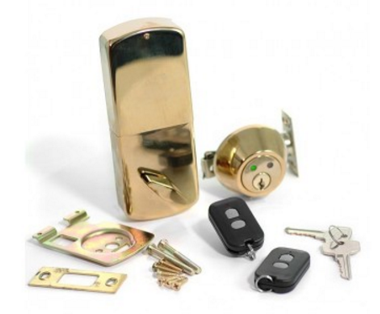 | There are both deadbolt (shown) and door handle options. This technology allows someone with limited mobility to lock and unlock their door without having to physically reach the mounted lock. It increases safety, especially for providing access to caregivers, and securing the home when caregivers leave. http://home-automation.smarthome.com/search?p=Q&lbc=smarthome&uid=182067473&ts=custom&w=remote%20controlled%20deadbolt&method=and&view=list&af=&isort=rating has a wide selection and prices vary.
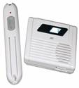  Doorbell with flashing strobe and chime: | These devices uses a transmitter to activate the receiver that can flash a bright strobe or and emits a loud chime. This device may benefit an individual who is hard of hearing, or an individual without a hearing impairment in a loud environment. http://www.rehabmart.com/category/Hearing_Impaired_Alert_Devices.htm
Flashing door beacon:  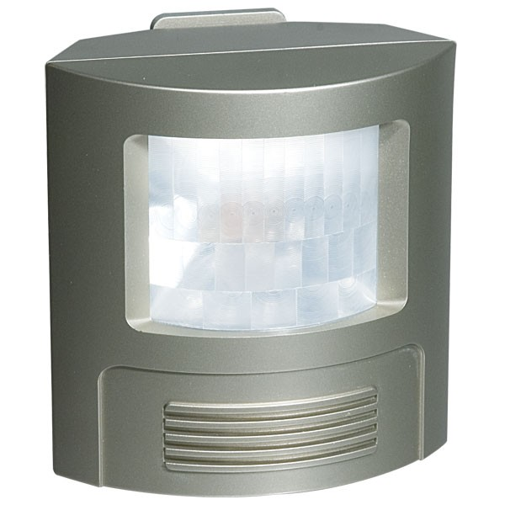 | The door beacon responds to the vibration caused by knocking on the door. The knocking shakes the beacon which causes it to flash in alert for several seconds. It has adjustable sensitivity and several mounting options that allow it to be moved between doors as needed http://www.rehabmart.com/product/the-door-beacon-door-knock-sensor-24569.html
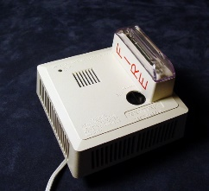  Flashing/ Silent call smoke alarm:  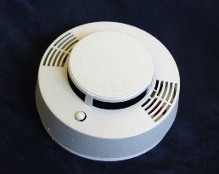 | These devices emit an audible signal as well as sends a silent signal to a silent transmitter (sold separately) to reliably alert both hearing and hearing impaired persons of the presence of smoke. There are both portable and hard-wired (requires an electrician) options. Some models have battery backup (which only activates the audible alert). A variety of options are available, and are available for review here: http://www.rehabmart.com/category/Hearing_Impaired_Alert_Devices.htm
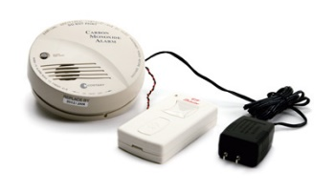  Flashing carbon monoxide alert: | This device emits a signal to a transmitter or strobe light (both purchased separately) to alert the user of an increased carbon monoxide levels. A variety of options are available, several of which can be purchased at http://www.rehabmart.com/category/Hearing_Impaired_Alert_Devices.htm
Emergency Alert Intercom system:  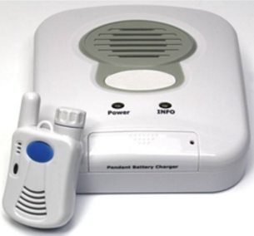 | An intercom system can increase the security of a users’ residence, as well as increase their comfort level of living alone.  Additional information available at: https://www.intercomsonline.com/Elderly-Disabled-Emergency-Alert-Intercom-p/35911.htm
Lifeline:  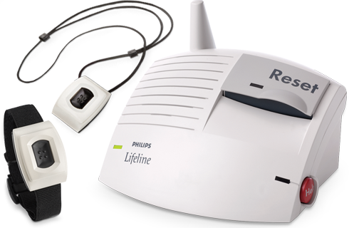 | Lifeline is a subscription based alert system that is recommended for individuals with complex medical conditions, limited mobility, at risk for falling or other accidents (e.g. heart attack, seizure). Users can have a pendant, charm or alternative access trigger. More information can be found at http://www.lifelinesys.com/content/

MOBILITY

Mobility impairments can create an unsafe living condition, as well as limit a person’s ability to be independent in and out of the home. Applying assistive technology to address mobility issues can allow a person freedom to complete tasks and hobbies around the home, as well as pursue hobbies outside the home.

One of these lower technology options may be appropriate:
- Traction grips on shoes and/or rugs
- Walking cane
- Handrails on both side of the stairs
- Non-slip reflective tape on stairs

Some higher technology examples that may benefit people with mobility limitations are provided below.

Alternative access remote controls:  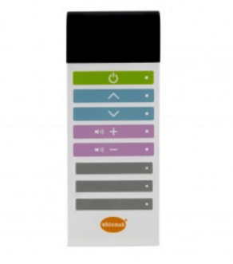 | Alternative access remote control can allows a device user to power on electronics and control their functions through touch, voice or switch button. This is beneficial for someone who has difficulty managing small buttons on a manufacturer remote due to impaired coordination, impaired strength or impaired vision. You can access several alternative remote controls here:  Ablenet Relax: https://www.ablenetinc.com/relax  XFINITY Voice Remote: https://www.xfinity.com/support/cable-tv/get-to-know-xr11-remote/  AnyMote voice activated universal remote app for Android mobile devices: https://play.google.com/store/apps/details?id=com.remotefairy4&hl=en
Insteon Wireless remote control system:  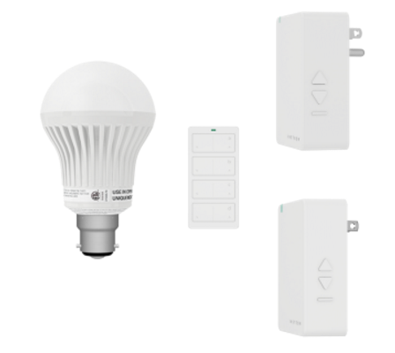 | A wireless Insteon system allows the user to remotely access electric devices such as lamps and fans with a handheld remote, a mounted keypad, or mobile device app. Additional information is available at:  http://www.insteon.com/plug-in-devices  http://www.smarthome.com/.

Reacher:  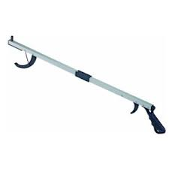 | A reacher can help the user grasp items out of reach while in or out of the home. It can weigh as little as a half pound, may have non-slip rubber lined jaws, and various types of trigger grips. Additional information is available at:  http://www.rehabmart.com/category/reachers.htm
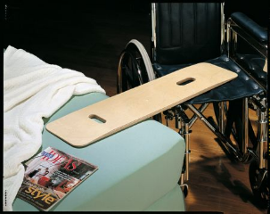  Transfer board: | Transfer boards, made of wood or plastic, can be used to assist with independent or assisted transfers from wheelchair to bed, toilet, commode, couch or chair. An individual’s transfer safety should be evaluated first by a qualified practitioner, usually an OT or PT.
Ice cane/crutch attachment:  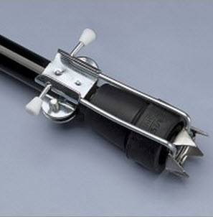 | A multi-pronged cleat aids a user in walking over icy areas. The attachment can be flipped up and out of the way when not in use. It’s made out of heavy duty steel and fits most crutches, walkers and canes. One model can be reviewed at:  http://www.rehabmart.com/product/norco-ice-grippers-6086.html
Shoe ice tread:  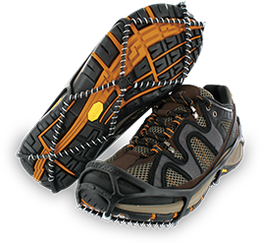 | Non-slip straps slip onto shoes to improve the user’s traction when on ice and/or snow. Some models slip over the entire heel of the shoe, others strap onto the front of the shows. They come in men and women’s sizes.  Additional information is available at:  https://www.yaktrax.com/product/walk
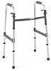  Walker: | A walker may improve stability for users who experience balance problems or muscle weakness. The metal frame is sturdy; most models feature adjustability and are foldable for storage and transportation. Consumer's transfer safety should be evaluated first by a qualified individual, usually an OT or PT.
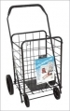  Wheeled laundry cart: | A wheeled cart can reduce lifting and carrying burden for laundry, groceries and other items. It can be useful for a person with impaired strength or balance.
Wheelchair:  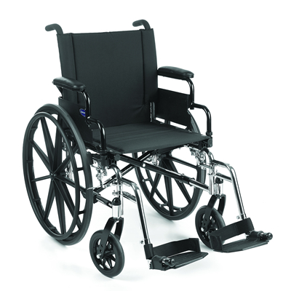 | A wheelchair can provide a form of mobility for someone with a low physical tolerance for walking, or provide positioning support for an individual who has postural weakness. An experienced seating and mobility specialist should be consulted before any wheeled mobility purchase.
Scooter:  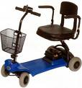 | A motorized three or four wheeled scooter can provide a mode of mobility for running errands or leisure activities in the home and community. An experienced seating and mobility specialist should be consulted before any wheeled mobility purchase.
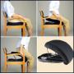  Seat lifters: | Mechanical, automated and portable seat lifters can assists an individual with rising from a seated position. An individual’s transfer safety should be evaluated first by a qualified practitioner, usually an OT or PT.
Automated and mechanical lifts:  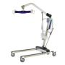 | Automated and mechanical lifts can provide complete assistance for individuals to transition between a bed, chair, commode or shower chair. An individual’s transfer safety should be evaluated first by a qualified practitioner, usually an OT or PT.
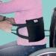  Transfer slings: | Transfer slings can distribute an individual’s weight load, and may improve safety and comfort during caregiver assisted transfers.  An individual’s transfer safety should be evaluated first by a qualified practitioner, usually an OT or PT.
SECTION B: ASSISTIVE TECHNOLOGY FOR PERSONAL CARE

EATING/COOKING

Individuals may have difficulty accessing conventional utensils for eating and food preparation.

You may find that one of these low-tech options may be sufficient:
- Sports water bottle for drinks
- bendable straws
- create non-skid surfaces

Some other technology examples that may benefit people with disabilities who have difficulty working independently in the kitchen or during meals are provided below.

Clip-on mug handle:  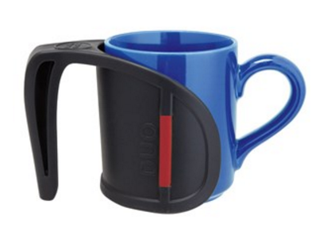 | This lightweight clip-on handle converts a conventional ceramic mug into a 2 handled mug. This might be useful for someone with tremors or limited grip strength. One model can be reviewed at: https://www.maxiaids.com/vivi-duo-handle-red-with-arthritis-friendly-grip-and-clip-on-design
Non-skid dishware: | Non-skid dishes are useful for wheelchair trays, bed tables, dining tables, and other mobile surfaces. Non-skid dishware improves stability during self-feeding tasks. Several devices can be reviewed at: http://www.caregiverproducts.com/site/270651/page/911661/bedridden-products
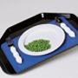  Non-skid mat: | Non-skid mats create a no-skid surface when using conventional dishware. These could be useful for individuals with tremors, muscle spasticity or poor gross/fine motor control. Several styles can be reviewed at: http://www.rehabmart.com/product/dycem-precut-pads-7775.html
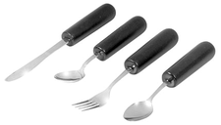  Adapted eating utensils: | Adapted eating utensils may have larger handle grips, supportive straps, and variable angles to improve self-feeding independence and success for individuals who experience weakness, tremor, and range of motion impairments. Several devices can be reviewed at: http://www.caregiverproducts.com/eating-utensils.html
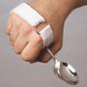  Utensil cuff: | A Utensil cuff can make it possible to hold utensils with limited grip strength. One model can be reviewed at: http://www.rehabmart.com/product/universal-cuff-utensil-holder-18620.html
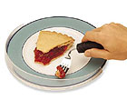  Plate Guards: | A plate guard can fit onto a conventional plate and allows users to scoop food up when using 1 hand to eat. One model can be reviewed at: http://www.rehabmart.com/product/surefit-clear-food-guard-67.html
A nosey cup:  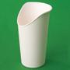 | A nosey cup has a cut out that allows an individual to drink from a cup without extending their neck backwards. It is designed for use by people who have limited movement in their head, neck and shoulders, or need to remain upright when drinking and swallowing. One model can be reviewed at: http://www.rehabmart.com/product/nosey-cups1-18554.html
Adapted Straws:  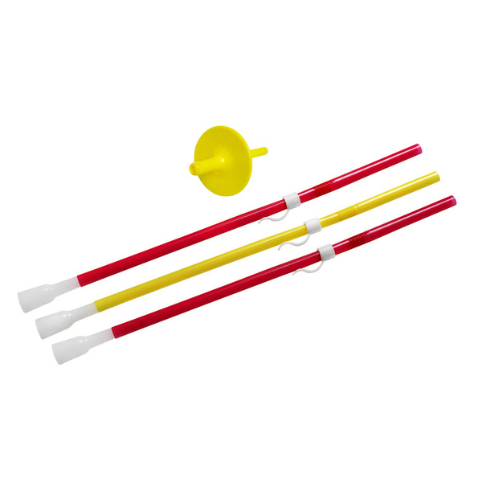 | Adapted straws may include valves that prevent liquid from leaving the straw, making it easier for individuals with oral motor impairments to drink from a straw. Several models can be reviewed here:  https://www.arktherapeutic.com/straws-valves/
Adapted Knives:  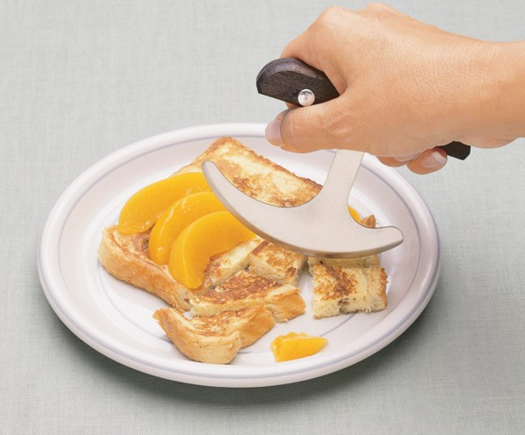 | Adapted knives may allow individuals to use 1 hand to cut with a rocking motion, or cut with a sawing motion. Several models can be reviewed here:  http://www.rehabmart.com/category/kitchen_knives.htm
A walker tray:  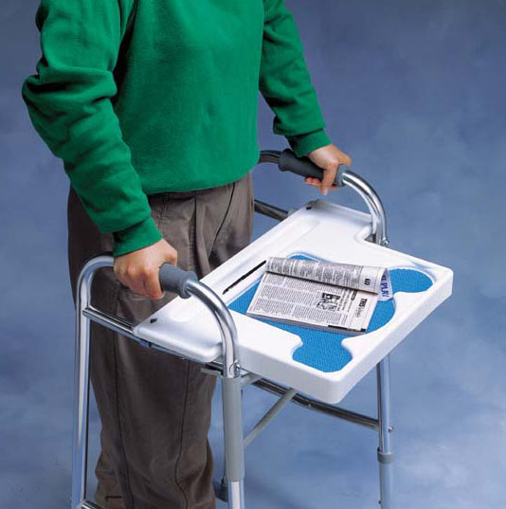 | A walker tray can fit on folding walkers, and allow the user to transport items, such as food and covered drinks, on a flat surface. One model can be reviewed here:  http://www.lifesolutionsplus.com/walker-tray-p-236.html

Adapted can openers:  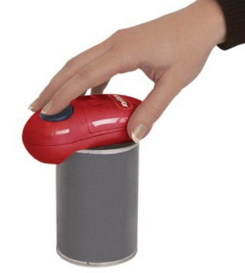 | Adapted can openers may be useful for people who have hand weakness and can only use one hand (e.g. arthritis, stroke). They may require no pressure after the cutter has been activated, and sometimes may have an automated shut-off. One model can be reviewed here: https://www.zyliss.com/shop/gadgets-tools/can-wine-openers-corkscrews/zyliss-easican-electric-can-opener/
Adapted scoop plates and bowls:  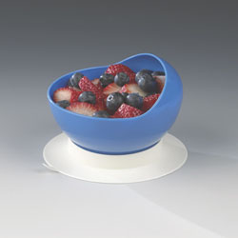 | Adapted plates and bowls have curved sides to improve scooping of some foods onto a utensil. Several models can be reviewed here:  http://www.maddak.com/eating-aids-adaptive-bowls-plates-and-accessories-c-1708_1732.html
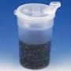  Flo-Trol cup: | A Flo-trol cup is designed to regulate liquid flow using finger placement over an air inlet hole opposite the mouthpiece. This cup is best for individuals who need assistance with limiting liquid flow when drinking.  http://www.alimed.com/flo-trol-drinking-cup.html
High contrast measuring cups:  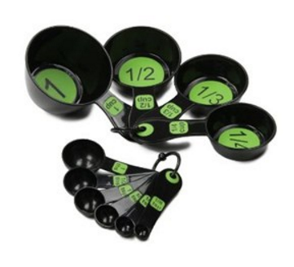 | High contrast measuring cups have easy to read numbers and are dark to improve measuring of light-colored ingredients. One model can be reviewed here:  https://www.maxiaids.com/measuring-spoons-with-large-print-set-6-black-green-2
Adapted Cutting Boards:  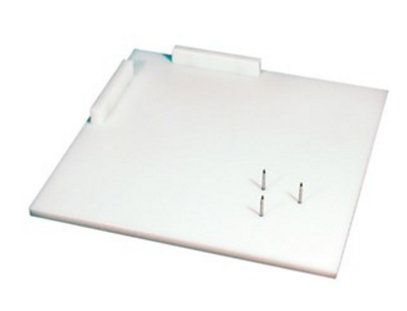 | Adapted cutting boards may feature corner guards, positioning spikes or clamps for stabilizing ingredients while cutting. One model can be reviewed here:  https://www.maxiaids.com/multi-purpose-cutting-board-white
Clip on vegetable peeler: 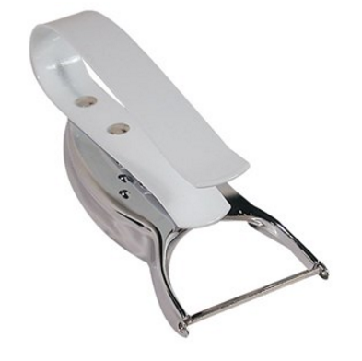 | A clip-on vegetable peeler has a slip-on handle which makes peeling vegetables much easier for people with impaired grip strength.  http://www.maxiaids.com/products/1069/Clip-on-Vegetable-Peeler.html

GROOMING/BATHING/DRESSING

Grooming, bathing and dressing tasks can present significant difficulties for people with a range of physical disabilities. Disabilities related to mobility and gross motor skills (e.g. Arthritis, muscle weakness, muscle spasms, tremors, balance, mobility) can especially make these tasks difficult. One of the following low technology adaptations may improve independence:

- Use a wooden spoon duct taped to an object to extend the handle of a grooming tool.
- In lieu of zipper rings, tie loops of fishing wire to zippers (less conspicuous).
- Hand mitt instead of a wash cloth
- Absorbent terrycloth robe instead of towel drying

Some higher technology examples that may benefit people with disabilities who have difficulty with grooming and dressing tasks are provided below.

Flexible stands for hairdryers:  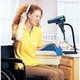 | Flexible stands for hairdryers let users blow dry their hair without having to hold the hair dryer. This would benefit individuals with muscle weakness, tremors, or other fine motor disabilities. One model can be reviewed at  http://www.arthritissupplies.com/hands-free-hair-dryer-stand.html
Long handled examination mirrors:  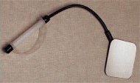 | Long handled examination mirrors can allow users to examine all parts of their body to maintain good skin health. One model can be reviewed here:  http://www.arthritissupplies.com/long-square-self-inspection-mirror.html
Extended /contoured handle grooming tools:  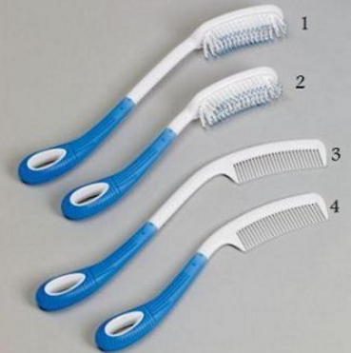 | Extended/contoured grooming tools are designed to be easy to hold and can improve reach. One model can be reviewed at: http://www.arthritissupplies.com/body-care-long-handle-brushes-and-combs.html
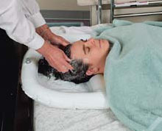  Adapted hair wash basins | Adapted hair wash basins can be inflatable, may attach to sinks, and may catch water when the user is sitting upright. One model can be reviewed at  https://www.activeforever.com/ableware-inflatable-crescent-shaped-shampoo-basin
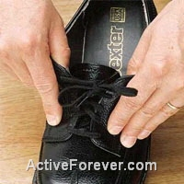  Elastic shoelaces: | Elastic shoelaces allow the user to convert standard lace-up shoes into slip-on style shoes. Once they are laced and tied into place the user can simply slip their foot into the shoe. The elastic expands slightly, and returns to its original position when the shoe is on. This may benefit users who have poor fine motor abilities, the use of only one hand or are unable to bend over to put on their shoes. One model can be reviewed at:  http://www.alimed.com/elastic-shoe-laces.html
Dressing sticks:  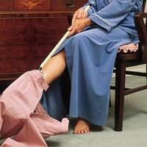 | Dressing sticks come in a range of style and options depending on the needs of the user. They usually have two hooks at one end and one hook on the other. They are used to accomplish all sorts of dressing tasks. Users with poor fine motor control, the use of only one hand, poor joint range of motion, or other similar difficulties may find these useful. Some examples can be found at https://www.ncmedical.com/item_298.html
Weighted grooming cuff:  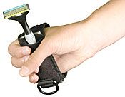 | A weighted grooming cuff may assist in reducing tremor during activities grooming activities such as shaving and oral care. May benefit users who have tremors or poor grip strength and are unable to independently hold the razor (e.g. stoke, muscle spasms, numbness). This model can be purchased at http://www.arthritissupplies.com/weighted-cuff-for-disposable-razors.html?gclid=
Suction base nail clippers: 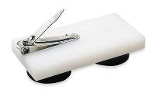 | A suction base nail clipper is designed to help people with fine motor impairments or weakness. The suction cups will stabilize the clipper to any smooth surface. These can be reviewed at http://www.caregiverproducts.com/site/270651/product/AMI220.
Adapted toenail scissors:  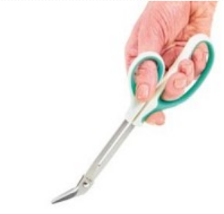 | The adapted toenail scissors have molded grips to enhance accuracy and allow the user to use the strength of their entire hand when trimming toenails. The angled blades provide a good cutting position. One model can be reviewed at http://www.arthritissupplies.com/long-reach-toenail-cutter.html
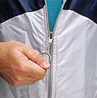  Zipper rings: | Zipper rings snap onto zippers to extend the pull tab. They may benefit users who have difficulty grasping and pulling small zipper tabs. This item can be reviewed at: http://www.lifesolutionsplus.com/ring-zipper-pull-p-188.html.
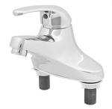  Single lever faucets: | Single lever faucets reduce the difficulty of turning the water on and off, as well as adjusting the temperature. They allow someone with low grip strength, low fine motor skills or an inability to turn a knob access to the sink. One model can be reviewed at: http://www.store.adaptivelivingstore.com/ada-compliant-classic-single-control-faucet-p1398.aspx
Bathmats with non-slip backing:  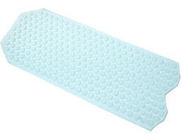 | Bath mats with non-slip backing help increase the safety of shower bathing. Suction cups on the bottom often anchor the mat to the bathtub or shower, and a textured surface reduces slipping. May be considered for an individual with decreased balance or limited mobility. One model can be reviewed at:  https://www.maxiaids.com/duro-med-non-slip-vinyl-shower-mat

No rinse bath wipes:  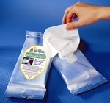 | No rinse bath wipes are alcohol free, pre-moistened disposable towels that help clean and deodorize when shower bathing is not an option. These may be beneficial for users who require personal care assistance and cannot take daily baths/showers, as well those users who desire to freshen up between baths. One brand can be reviewed at:  http://www.caregiverproducts.com/no-rinse-bathing-wipes.html
No rinse shampoo cap:   | A no rinse shampoo cap is a latex and alcohol free cap that allows for cleansing of hair without the need of a running water rinse. One brand can be reviewed at:  http://www.caregiverproducts.com/no-rinse-shampoo-cap.html
Touch-free automatic soap dispenser:  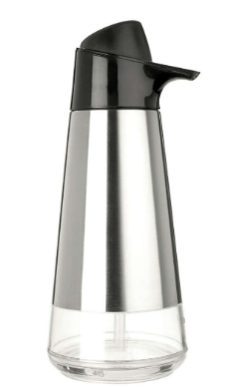 | A touch free automatic soap dispenser is a battery operated device that is triggered by a motion sensor and delivers a measured amount of liquid soap. One model can be reviewed at:  https://www.oxo.com/products/cleaning-laundry/soap-dispensers/stainless-steel-soap-dispenser
Transfer bath benches:  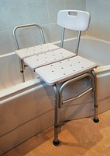 | Transfer bath benches can allow an individual with mobility impairments to swing legs into a tub while in a seated positon. Features include rotating seat, hand rails, cutout for handheld shower, padding, and commode cut-out seat. An individual’s transfer safety should be evaluated first by a qualified individual, usually an OT or PT.
Silicone ear plugs:  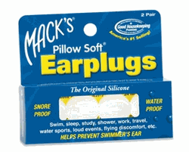 | Silicon ear plugs provide barrier protection to prevent water from entering the ear canal. They are disposable and can be purchased at most pharmacies.
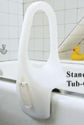  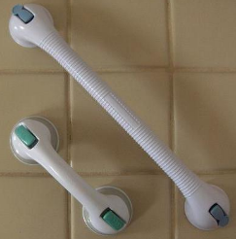  Portable grab bars: | Bath Portable grab bars are appropriate when a stationary bar cannot be installed, or when the user needs only steadying assistance. These devices install with suction cup to smooth tile and bath surrounds, and provide some additional support when stepping in and out of the bath/shower, but must be inspected often to ensure they remain secure. An individual’s transfer safety should be evaluated first by a qualified individual, usually an OT or PT.
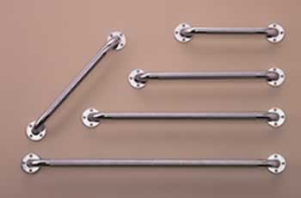  Installed stationary grab bars: | Installed stationary grab bars can be installed anywhere in a home to add support. Installation should be performed by a professional, as it may require walls to be reinforced in order to hold the users weight. An individual’s transfer safety should be evaluated first by a qualified individual, usually an OT or PT. These need to be installed by a qualified professional.
Vertical transfer bars:  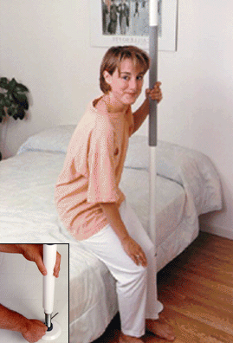 | A vertical transfer bar is often mounted between the floor and ceiling, and are appropriate for people who require a moderate amount of support transferring. An individual’s transfer safety should be evaluated first by a qualified individual, usually an OT or PT.  One model can be reviewed here:  http://www.rehabmart.com/product/guardian-safetpole-26027.html
Bath lifts:  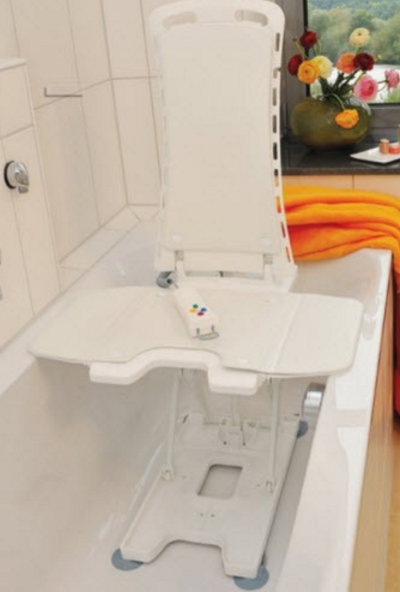 | Bath lifts allows a user to transfer to a chair in the tub, and lower safely into a tub for a submerged bath, This technology would benefit someone who is not fully independent for transfers, as well as someone who is ambulatory, but unable to lower themselves into the tub and stand up to get out of the tub. An individual’s transfer safety should be evaluated first by a qualified individual, usually an OT or PT.  One model can be reviewed at: http://www.rehabmart.com/product/bellavita-automatic-bath-lifter-33996.html
Raised toilet seat: 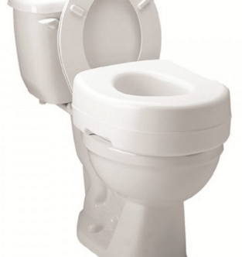 | A raised toilet seat can raise the height of the existing seat without structural modifications to a bathroom. This type of adaptation may be useful for individuals with limited endurance, balance and/or strength. An individual’s transfer safety should be evaluated first by a qualified individual, usually an OT or PT.  Several models can be reviewed at: https://www.activeforever.com/bath-safety/raised-toilet-seats
Bidet toilet seats  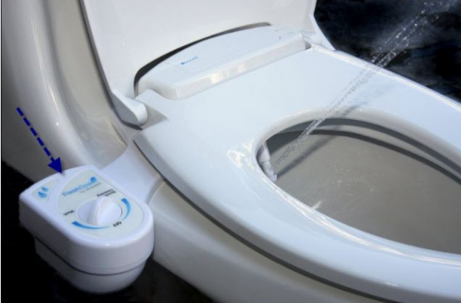 | Bidet toilet seats can provide automatic flushing and hygiene assistance. This piece of equipment would benefit an individual who requires assistance with toilet hygiene. There are a variety of models with different features, depending on the users’ and needs. One model can be reviewed here: http://www.rehabmart.com/product/brondell-freshspa-bidet-attachment-34923.html
Foot Flush:  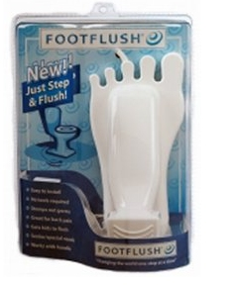 | The foot flush hands free flusher allows the user to flush the toilet with a light foot pressure. This may be beneficial for someone with limited fine motor abilities or who is unable to use a standard lever flusher on the toilet. This item can be reviewed here: http://www.medicalproductsdirect.com/toflfunfofl.html?
Bedside and Over Toilet Commodes:  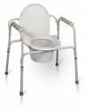 | Bedside and over toilet commodes allow for toileting outside of the bathroom, as well as sturdy armrests to assist with standing. An individual’s transfer safety should be evaluated first by a qualified individual, usually an OT or PT.
Electronic Medication dispenser:  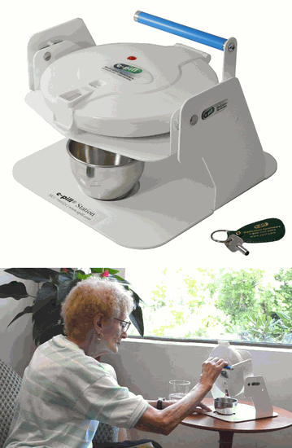 | Electronic medication dispensers have several features including multiple pill alarms and alerts, recordable voice alerts, smart locking to prevent overdosing, synchronization with mobile devices, and off-site caregiver monitoring. One model can be reviewed here:  http://www.epill.com/epillstation.html
Adapted pill boxes:  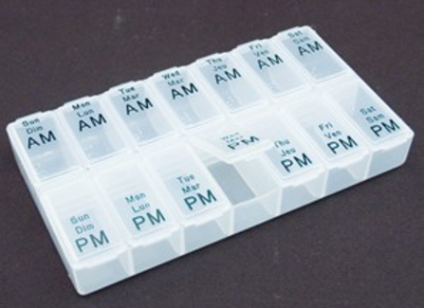 | Adapted pill boxes may have features including tactile and high contrast markers for days of the week and time of day, large door closers for easy access and operation, and large compartments for large medications. This item can be reviewed at: https://www.maxiaids.com/jumbo-pill-box-clear-braille
Magnifying Pill Cutter:  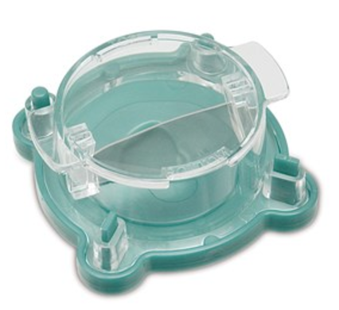 | A magnifying pill cutter helps a user make sure their pill is cut exactly in half, when required. The pill is placed in the holder, with a 2x magnifying lid, and then the steel blade is pushed onto the tablet. Halves can be stored in the container. This item can be reviewed at:  https://www.maxiaids.com/pill-cutter-with-magnifier

SECTION C: ASSISTIVE TECHNOLOGY TO AID WITH COGNITION AND MEMORY TASKS

Head-trauma, general aging or the onset of neurological conditions can affect ones memory. This can often have an impact on one’s ability to complete daily tasks and live independently.

One of these options may be appropriate:
- Post visual cues
- Create daily checklists
- Create a wall calendar for appointments

Assistive technology for people with memory and cognitive impairments might include:

Vibrating alarm watch:  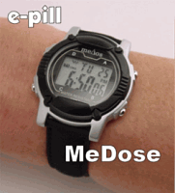 | These devices provide scheduled vibration and/or sound alarms that can be used to remind a user to use the bathroom, take medication or complete another task. The reminders range from a few reminders a day up to 30. They can be programmed with a short message that appears with the alarm to inform the user why the alarm sounded. Many models look like a normal sports watch and tells real time. Prices vary. https://www.maxiaids.com/vibrating-watches
Mobile device such as iPod Touch or Android tablet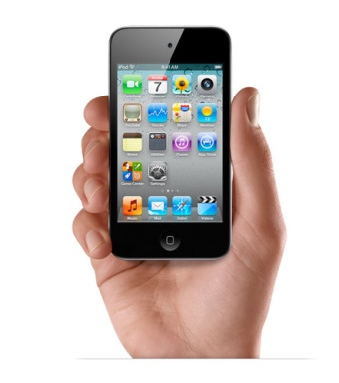 | A mobile device can be greatly beneficial in assisting users with cognitive deficits in maintaining their schedule, remembering their appointments or taking notes from meetings. Many mobile devices have built in calendars and systems for creating reminders and alerts. The addition of apps that target memory and organization can also be helpful. https://www.apple.com/ipod-touch/  https://www.android.com/tablets/
Tap memo voice activated PDA:  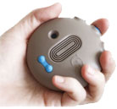 | The Tap memo is a revolutionary, handheld, battery powered voice activated personal data assistant. It contains only one multi-functional button and two volume buttons. All verbal commands are Speaker Independent which means the user does not need to train the unit – it will work 'right out of the box'. This type of device can be useful for people with cognitive deficits which affect memory. They can be used to remind the user of errands, messages or a to-do list. It can be purchased at http://library.rehabmart.com/post/voice-activated-pda-offers-the-blind-and-visually-impaired-a-personal-information-manager
Moshi Interactive Talking Alarm Clock  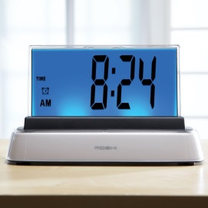 | Moshi can share time, date, temperature and more through voice commands alone. You can also set the alarm with your voice. This device is also appropriate for people with visual impairments.  http://www.independentliving.com/prodinfo.asp?number=247519  Available through various retailers, including Amazon
Talking calculator:  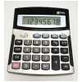 | A talking calculator is useful for a user who is blind or has low vision. The buttons and display are larger than a standard calculator.  https://www.maxiaids.com/talking-calculators
Sonic Boom Alarm Clock:  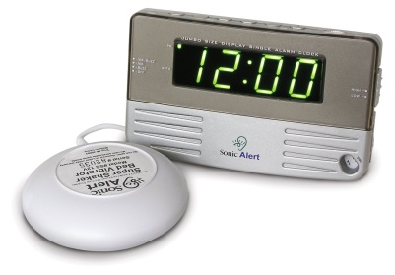 | The Sonic Boom alarm clock will wake up even the heaviest sleeper. The user can select to wake up to any combination of loud pulsating audio alarm, flashing lights, or shaking bed vibrator. This would benefit a user with a hearing impairment, and help assure they wake up on time and make their appointments.  http://www.sonicalert.com/Alarm-Clocks-s/1819.htm

SECTION D: ASSISTIVE TECHNOLOGY FOR HOME MANAGEMENT

CHORES/CLEANING/ERRANDS

Cleaning, chores and running errands can present serious difficulties for people with a range of disabilities. Disabilities especially related to mobility can create unsafe conditions for someone to independently do chores and run errands. Persons with disabilities that effect gross and fine motor skills (e.g. grip strength, muscle control, balance, mobility) can also benefit from assistive technology related to cleaning, chores and errands.

Some higher technology examples that may benefit people with disabilities who have difficulty with cleaning, chores and errands are provided below.
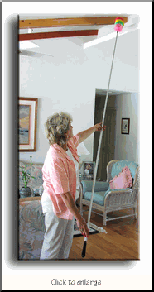  Long handled Duster: | This is a 20 foot rod with a duster on the end. It allows for the user to keep their feet on the ground, or remain seated and be able to dust high, out of reach places (e.g. ceiling fans, hanging plants, corners of high ceilings). One model can be purchased at  https://www.amazon.com/Telescoping-Microfiber-Duster-Pole-Ceilings/dp/B0046NRC6M
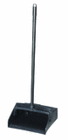  Long handled dustpan: | This product allows the user to collect sweepings without having to physically bend over. This would benefit someone with a mobility or balance impairment, joint pain or similar conditions. They can be purchased through many hardware stores.  https://www.walmart.com/ip/Miles-Kimball-Red-Long-Handeld-Dust-Pan-With-Broom/37516222
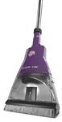  Electric Broom: | This allows a user to sweep without the use of a dustpan, and with minimal motion. Prices vary.  https://www.amazon.com/Best-Sellers-Home-Kitchen-Stick-Vacuums-Electric-Brooms/zgbs/home-garden/510112
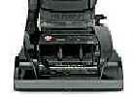  Self-propelled Vacuums: | These are useful for people who have limited strength, poor physical tolerance for activity, balance impairments or mobility impairments. A self-propelled vacuum may allow a user to vacuum independently when it would not otherwise be possible. Prices vary.  http://www.allbrands.com/categories/1134
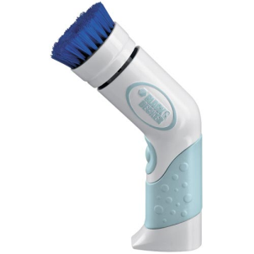  Power scrubber: | This is a battery powered scrubbing tool that allows for the user to clean without having to scrub. This would benefit someone with a strength or range of motion impairment that prevents them from applying force or using back-and-forth or circular motions. http://www.amazon.com/Black-Decker-PKS160-Power-Scrubber/dp/B001EWEV26
Wheeled cart for laundry: | Using a wheeled cart to transport laundry or when running errands eliminates the needs to carry most items one would purchase (e.g. pharmacy, grocery store items, and general shopping) or laundry. It would be useful for a person with limited strength or balance to complete laundry tasks or safely transport purchased items to their home. A couple of alternatives would be a mesh laundry bag so that they can be dragged or using a child’s wagon.  https://www.amazon.com/EasyComforts-Laundry-Cart-With-Wheels/dp/B00NW2UTUE
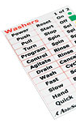  Large print washer/dryer labels: | These low vision overlays increase the size of the text on the washer/dryer. They have large, bold text that will help identify small, hard to read buttons. A set comes with 104 stickers. They can be paired to create more accurate labels. Can be purchased at  https://www.maxiaids.com/ablesee-large-print-overlays-washing-machine
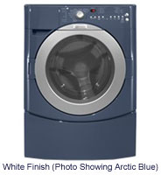  Front loading washing machine: | Front loading washers increase independence because clothes can be put in and taken out of the washer without standing and reaching, and also because the controls are on the front of the washer instead of the top.  http://www.bestbuy.com/site/washers-washing-machines/front-loading-washers/abcat0910002.c?id=abcat0910002
Hangers with rotating hooks:  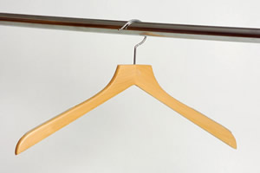 | These hangers will make hanging clothes a less physically tiring task for people with a low physical tolerance or who are unable to hold the hanger and put the clothes on simultaneously.  https://www.amazon.com/Crystal-Plastic-Hangers-Rotating-REGULAR/dp/B002Y3WONC

MONEY MANAGEMENT/DAILY TASKS

Basic daily tasks and independent money management can become difficult tasks for someone with motor or vision impairments, as well as other disabilities. Some low and higher technology examples that may benefit people with disabilities who have difficulty with daily tasks (e.g. writing) and money management tasks are provided below.

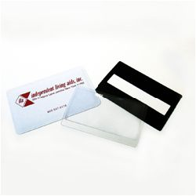  Sheet magnifiers: | Sheet magnifiers come in a variety of sizes and can be used with something like a checkbook, or full page documents, such as bills or money management documents. They can also be used for non money management tasks like reading menus, maps, books and more. The smaller ones fit easily in a pocket or on a key chain. May help someone with low vision or tremors.  https://www.magnifyingaids.com/Page_Magnifiers
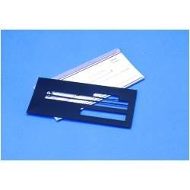  Plastic check writing guide: | The check writing guide can help people with a vision impairment that makes tracking across lines of text difficult, or people with tremors continue to pay their own bills. Available in standard or business check sized http://www.maxiaids.com/products/1252/KEITZER-Check-Writing-Guide.html
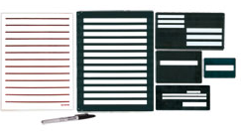  Metal writing guides: | The complete set of writing guides helps persons with low-vision to complete a range of writing tasks. The stencil like guides can help with letter writing, checks, addressing envelops, and signing documents. The set comes with a 20/20 pen and 20 sheets of bold lined writing paper. A 20/20 pen has bold ink and thicker writing tip to make writing easier to see. One model can be purchased at  https://www.amazon.com/Metal-Writing-Guide-BoldWriter-Vision/dp/B00JV57UKI
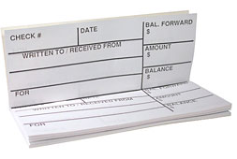  Large print check register: | This product provides large, bold headings and larger amounts of space to enter check data. Each transaction is recorded on its own page. Each register provides for 40 entries. One model can be purchased at: http://www.maxiaids.com/products/1578/The-Giant-Print-Check-Register.html
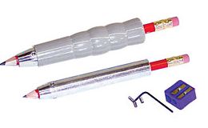  Weighted universal holders: | These will hold most round or irregular shaped pens and pencils. The set comes with 2 pen and pencil holders, a pencil, a pencil sharpener, and an Allen wrench and tiny screws to adjust for smaller objects. These holders will benefit someone with poor grip strength who has difficulty holding onto a typical pen or pencil. The can also benefit someone with tremors as the added weight can sometimes help improve penmanship. One style can be purchased at https://www.amazon.com/Kinsman-Weighted-Universal-Pediatric-Diameter/dp/B001ANRPSQ
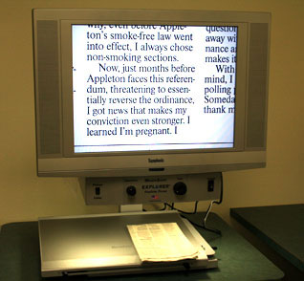  Closed Circuit Televisions (CCTVs): | These devices magnify items from 2x to 40x using a 14” television monitor and up to 75x using a 20” television monitor. Users can use this to fill out forms, read documents, read labels from medication bottles or food items or to magnify the paper so they can write a letter. This type of technology can greatly increase the level of independence someone with low vision is able to experience. Each model is different, and offer different controls for color combinations, black/white reversal, brightness, contrast, light settings. Most models have continuous and auto focus features. http://www.enhancedvision.com/low-vision-product-line.html

RECREATION/ENVIRONMENTAL CONTROL

Recreational activities are an important aspect of a person’s life, whether it be something out in the community or reading a book or playing a game at home. It is also important in an independent living situation that the consumer have the ability to control aspects of the environment (e.g. lights and television). Some high technology options for these areas of living are discussed below.

Electronic Aids for Daily Living (EADL) systems:  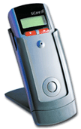 | These systems allow the user to access their environment using a remote control type device (accessible with a switch or by direct selection) or voice activated device. These systems are complicated to set up, but easy to use. This type of device should be recommended only by a qualified Assistive Technology Specialist.  http://atwiki.assistivetech.net/index.php/Electronic_Aids_to_Daily_Living_(EADLs)
Computer and Internet: | If a person has limited mobility and is unable to get into the community to run errands and do their shopping, being able to shop via Internet (e.g. www.peapod.com/ ). Additionally, the computer can be used as a means of communication and recreations (e.g. email, news, games) that may relieve a sense of loneliness that comes with living alone and having limited ability to experience the community.
Adapted Sports | There are many state parks which offer opportunities.  http://www.achievementcenters.org/adapted-sports.html

SECTION E: ASSISTIVE TECHNOLOGY TO AID COMMUNICATION

Augmentative Communication (AAC)
There are a number of disabilities that may result in a speech impairment. If there is serious concern about an inability to communicate, it may be necessary to schedule an assessment with a certified Speech-Language Pathologist for specialized recommendations. For clients who have difficulty using speech as their primary means of communication, the following items may be appropriate:

- Dedicated augmentative communication device (e.g., Nova Chat, Tobii)
- iPad with Augmentative Communication app
- Low tech device such as Go Talk
- AAC paper communication displays with pictures or letters

High technology AAC options:  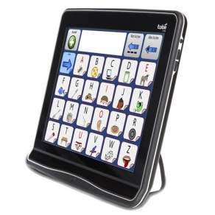  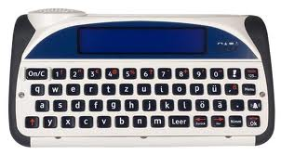 | Dedicated augmentative communication offer dynamic displays (users can move from page to page independently by pressing buttons on the screen), synthesized voice output, multiple options for alternative access for individuals who have physical disabilities. Offers storage and retrieval of large numbers of messages.  https://www.ussaac.org/aac-devices
Mobile Device Options:  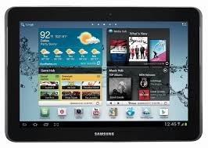  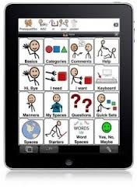 | Mobile devices offer a variety of communication options, depending on which app is used. Users can select pictures or type out messages, and the number of available messages can vary from one to thousands. Options for alternative access are increasing as well.
Low Tech AAC Options:  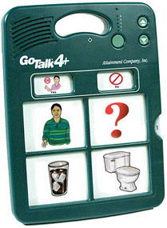  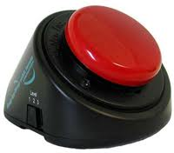 | Low tech AAC devices offer digitized voice output, multiple messages, static displays (paper displays that need to be changed manually) and little to no options for alternative access for those with physical challenges.
Non electronic options:  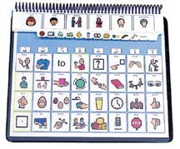 | Communication displays:  Picture based  Letter based  Phrases  Photo albums

Assisting Social Interaction:
A lack of social interaction can cause loneliness when living independently. There are several other assistive technology options that may aid in increasing communication between the user and their friends and family, especially if the user has a physical disability that prevents them from accessing a standard phone or computer.

A computer with internet access may be beneficial to increase a user’s communication with friends and family through email, video chatting or social media. For users with a physical disability that prevents them from directly accessing a computer there are a variety of assistive technology options to allow access.

For people with vision or hearing loss:

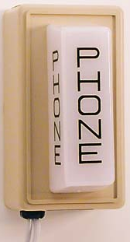  Telestrobe telephone ring signaler: | A telestrobe telephone ringer alerts someone who is deaf or hard of hearing to a telephone ring by providing a bright, flashing light. Unit plugs into both phone unit and electrical outlet. These can help assure someone with a hearing impairment does not miss phone calls.  http://www.harriscomm.com/telstrobe-telephone-ring-signaler-with-phone-connection.html
Clear voice 100A emergency telephone:  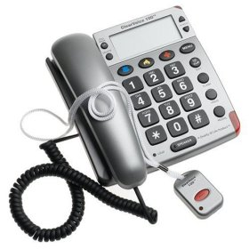 | This is a full featured amplified telephone for people with partial hearing and/or sight loss. It includes wireless remote for pickup of incoming phone calls and to speak from a distance, a talking Caller ID, Telemergency' renowned Emergency Help System. The emergency system automatically activates the speaker phone from up to 20 feet away with the press of a button and calls up to 10 entered emergency numbers from the phone directory in sequence sending to each called number the emergency message. It includes an adjustable amplified handset with tone controls. It features many audio feedback features (e.g. keypad, phone book, call waiting), a super loud ringer (adjustable) with strobe light, and unanswered call alert. https://www.amazon.com/Telemergency-ClearVoice-2000-Emergency-Telephone/dp/B000EGLYGY/ref=cm_cr_arp_d_product_top?ie=UTF8
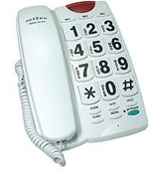  Large button speaker phone: | This style of phone can be help alleviate the difficulty in using the phone for someone with low-vision. It features large, easy-to-see black on white buttons, a 10 number speed dialing, flashing ringer light, ringer volume control and both desk and wall mounting options. Various models are available. Cost varies.  https://www.independentliving.com/products.asp?dept=198&deptname=
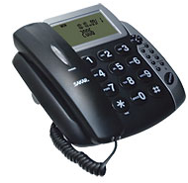  Talking Caller ID speaker phone: | This style of phone can be help alleviate the difficulty in using the phone for someone with low-vision. It features large, easy-to-see buttons, and also a talking caller ID (in 10 languages), a 110 number phone book, 90 call caller ID memory, and a range of ringer melodies.  https://www.independentliving.com/products.asp?dept=204&deptname=
Amplified cordless telephone with talking caller ID and phone book:  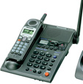 | This phone has easy to see buttons on the speaker phone, as well as a cordless phone with amplification. It features a talking caller ID as well as a talking phone book that speaks back a pre-recorded name and number when you are searching for a contact, a talking keypad to confirm numbers as pressed, and a hearing aid compatible headset jack.  https://www.independentliving.com/products.asp?dept=204&deptname=
Amplified Answering machine:  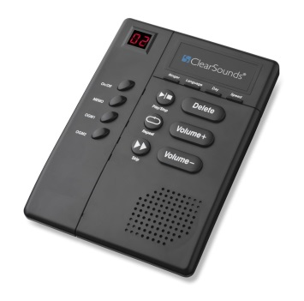 | An amplified digital answering machine has a high fidelity speaker to produce a clear sound, tone control to help you distinguish between callers and words and speed control. It comes with a separate mailbox for TTY messages. It can be purchased at http://www.amazon.com/ClearSounds-Digital-Amplified-Answering-ANS3000/dp/B00485PHCE/?tag=digitalca0daa06-20 .
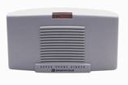  Super phone ringer: | This device generates an extra loud ring and offers a choice of four ring patters to help find the one someone with hearing loss might hear. It has volume control and a bight visual ring indicator. Available at Best Buy for under $40.00.  https://www.amazon.com/Clarity-Amplified-Telephone-Indicator-SR200/dp/B00009WCBT
SECTION F: ASSISTIVE TECHNOLOGY TO IMPROVE COMMUNITY / LEISURE ACTIVITY INVOLVEMENT

Community involvement activities can be a large part of happily living independently. Someone with a motor or mobility impairment may encounter a decrease in their ability to get out in the environment. Some of the following technologies may be beneficial in assisting users with reestablishing their community involvement and enabling their ability to participate their desired leisure activities.

In the case that an inability to provide one’s own transportation is preventing community involvement and participating in leisure activities, consider the following options:
- Adaptive cars
- Public transportation
- Volunteer drivers
- Organized group trips

Some higher technology examples that may benefit people desiring to increase the community and recreational involvement are provided below.

Car transfer assistant:  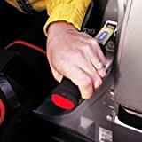 | This tool is designed to help a person lower themselves onto the car seat from a standing position. http://www.amazon.com/s/?ie=UTF8&keywords=handybar&tag=googhydr-20&index=aps&hvadid=44285624941&hvpos=1t1&hvexid=&hvnetw=g&hvrand=3168872158389844758&hvpone=&hvptwo=&hvqmt=e&hvdev=c&ref=pd_sl_94b8zk9qs1_e
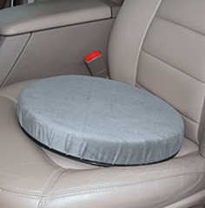  Car padded swivel seat: | This device is light weight and portable and makes turning in a car seat easier. The seat swivels 360 degrees and is helpful in getting in and out of a vehicle (not recommended with bucket seats). It supports up to 500 pounds. This device can reduce some of the muscle and joint strain that is caused by getting out of a vehicle.  http://www.amazon.com/Duro-Med-Degree-Swivel-Cushion-Capacity/dp/B0001X22WK/ref=sr_1_1?ie=UTF8&qid=1405431721&sr=8-1&keywords=padded+swivel+seat+cushion
Car caddie:  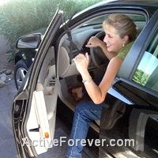 | This device attached to the frame of a car or truck door and offers additional balance and support to help a user get in and out of a vehicle. It features an adjustable strap and cushioned grip. This can be useful for someone with poor balance or muscle weakness.  http://www.amazon.com/Stander-2080-CarCaddie/dp/B000GUDGUU/ref=sr_1_1?ie=UTF8&qid=1405431748&sr=8-1&keywords=car+caddie
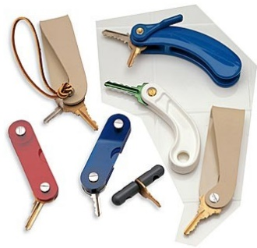  Large handled key holder: | These devices are useful for someone with muscle weakness, weak grip strength, arthritis or other fine motor impairments. The curved and heavy handles provide extra leverage and an easier grip, making turning the key easier. They can hold three keys and can be folded into the handle when not in use. They measure around 5” long and 1” wide.  http://www.amazon.com/Brand-New-Oversize-Tightening-ARTHRITIS/dp/B008IG6EYO/ref=sr_1_8?ie=UTF8&qid=1405431813&sr=8-8&keywords=large+handle+key+holder
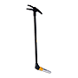  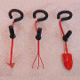  Gardening tools: | There are a variety of gardening tools that are designed to limit the amount of grip strength required to use the tools, as well as allow the tools to be used in a more comfortable posture. This form of tool may benefit someone with a fine motor impairment, limited grip strength or who is unable to sit on the ground to work in the garden. The following website provide some example technologies: www.oxo.com
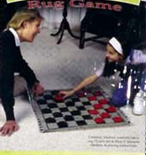  Board Games: | There are a variety of board games designed with larger game pieces or larger print on the board/pieces. http://www.amazon.com/Jumbo-Checkers-reversible-Midway-Monsters/dp/B00HYG7O8O/ref=sr_1_1?ie=UTF8&qid=1405431938&sr=8-1&keywords=large+checker+board
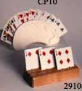  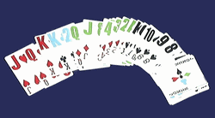  Playing cards: | Playing cards can be an easy and fun way to pass time. Large print playing cards provide larger numbers and icons to assist players with a vision impairment participate in their favorite card games. Card holders enable players with a motor impairment to play their favorite games without the strain of holding the playing cards. Several options can be purchased at or http://www.seniorstore.com/hob-0033.html . Braille playing card can be purchased at http://www.amazon.com/The-Braille-Superstore-Playing-Plastic/dp/B0093QD3RO/ref=sr_1_1?ie=UTF8&qid=1405432008&sr=8-1&keywords=braille+playing+cards

SECTION G: ASSISITIVE TECHNOLOGY RESOURCES

For the most comprehensive and current information available regarding assistive technology services, demonstration and loan programs, funding and information in Massachusetts, contact MassMATCH at:

MassMATCH
Massachusetts Rehabilitation Commission
600 Washington Street
Boston, MA 02111

877-508-3974 (Toll Free)
617-204-3851 (V)
617-204-3815 (TTY)
617-204-3877 (F)

Email: info@massmatch.org

www.MassMATCH.org

MassMATCH is funded by the U.S. Department of Health and Human Services (HHS) under the Assistive Technology Act of 1998, as amended. No official endorsement by HHS of any product, commodity or services mentioned in this guide is intended or should be inferred.

